**Document for start your project**

**For backend need to follow below steps**:

For download node js use this url:-<https://nodejs.org/en/download>

For run the backend node js code

First run :- npm i on terminal

Then “node index.js “ on terminal for run your backend code. Api doc url - <https://docs.google.com/document/d/1VcL2108I3QDMlDNO9yLM09N_5C_BGjDtuLgfzHPp-zc/edit?usp=sharing>

**For MongoDB data base setup need to follow below steps:**

1. Download MongoDB <url:-> <https://www.mongodb.com/try/download/community>

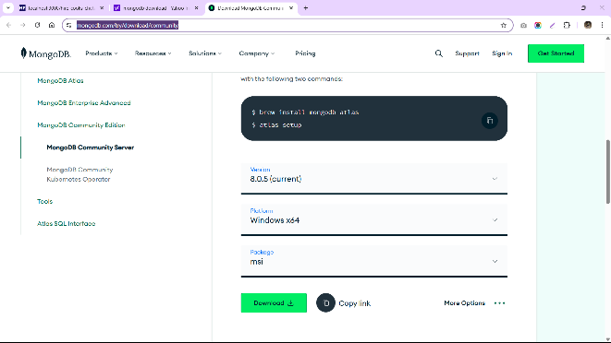 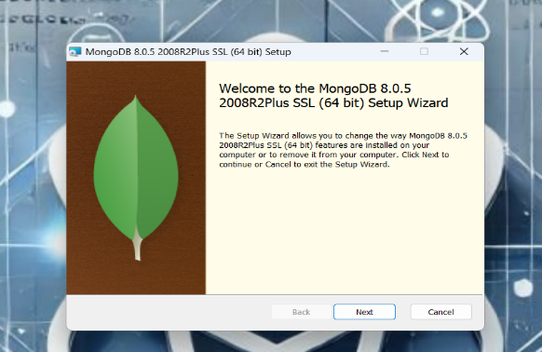

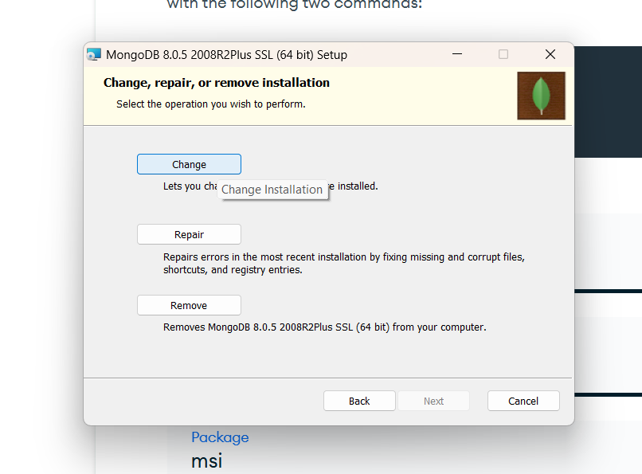 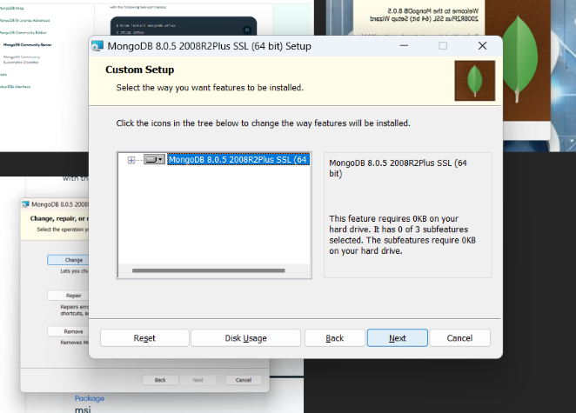

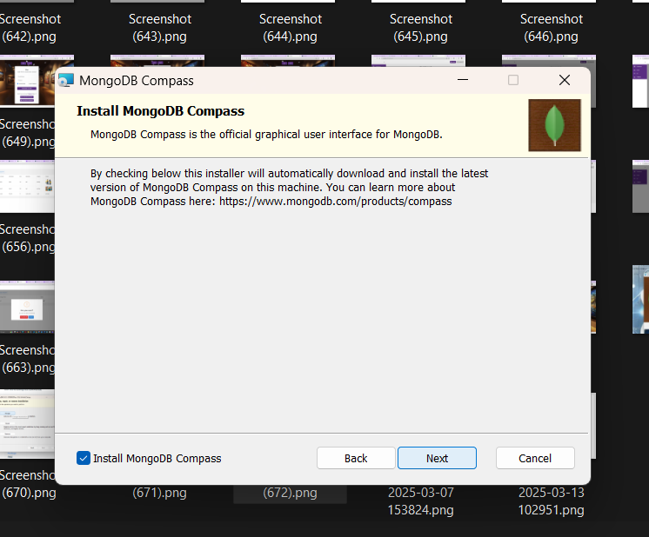 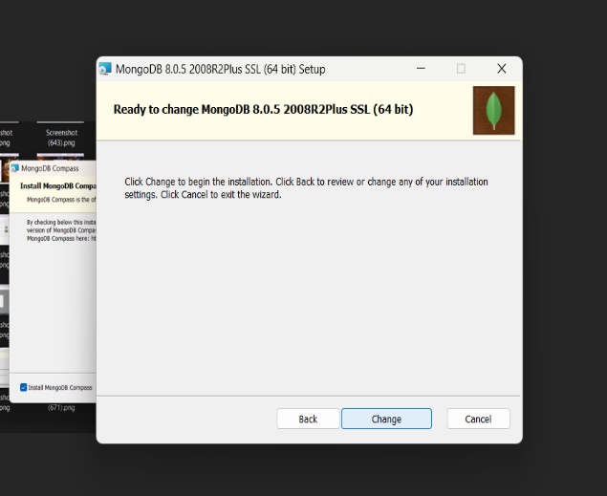

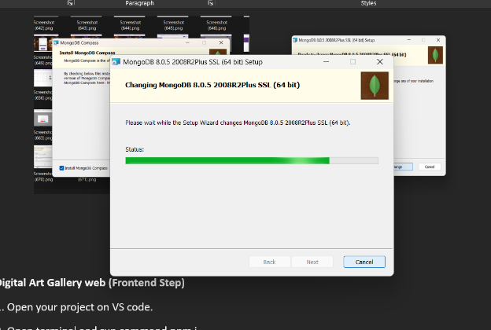

1. Download MongoDB compass

url :- <https://www.mongodb.com/products/tools/compass>

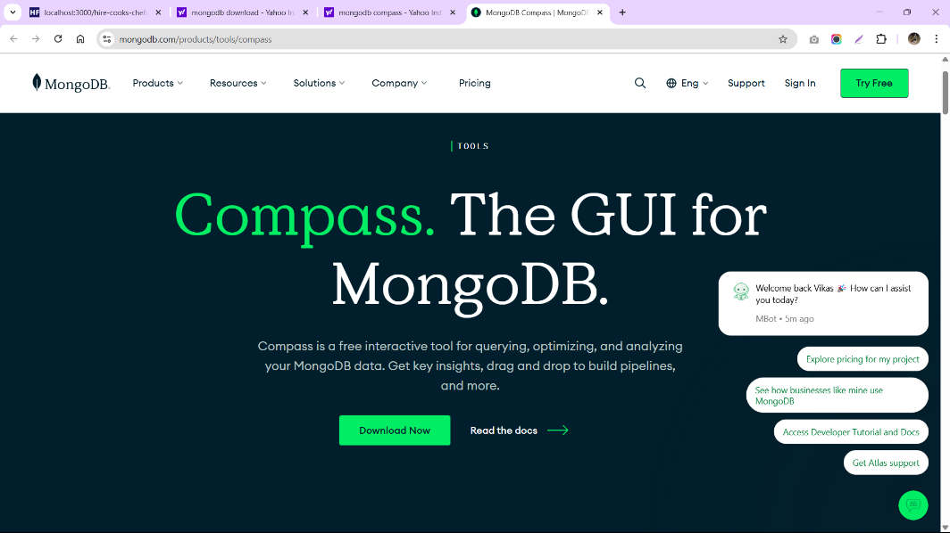

1. After installing open it and click to connect button.

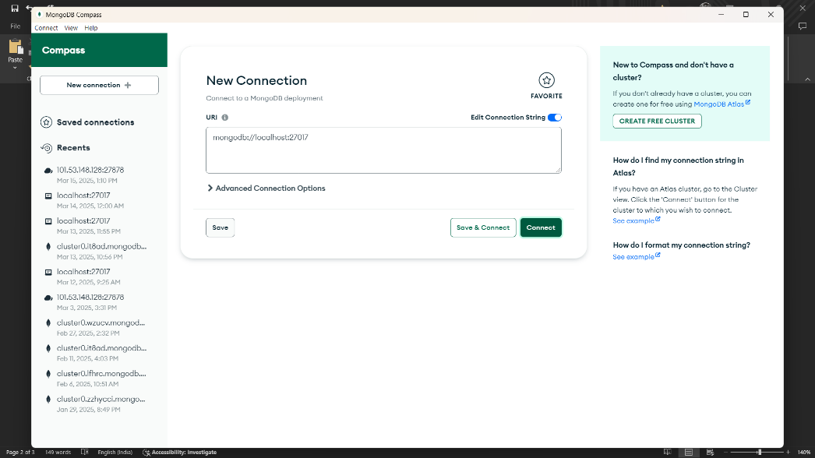

**Digital Art Gallery web (Frontend Step)**

1. Open your project on VS code.
2. Open terminal and run command npm i .
3. After installing run command npm start. Your project will be start in chrome browser.

**Digital Art Gallery admin (Frontend Step)**

1. Open your project on VS code.
2. Open terminal and run command npm i .
3. After installing run command npm start. Your project will be start in chrome browser.
4. Install Postman.
   * + 1. Download <Url:-> <https://www.postman.com/downloads/>
       2. Select Api type POST.
       3. Put Api <Url:-> <http://localhost:80/api/createAdmin>
       4. In Body Select row.
       5. After select row click in drop down and select JSON.
       6. Past body request data.

{

    "admin_Name”: "Admin",

    "admin_Email”: "admin@gmail.com",

    "password”: "123456"

}

* + - 1. And click to Send button.
      2. Screen Shot.

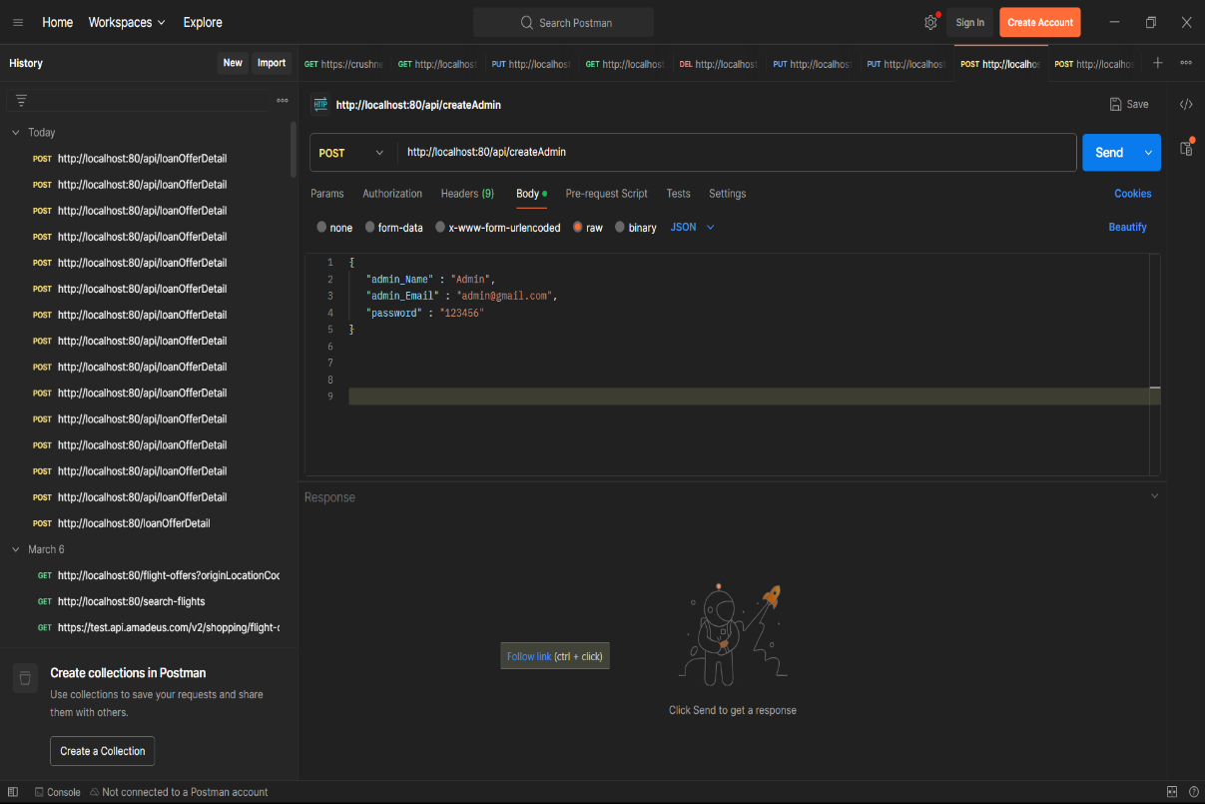

* + - 1. After get Api response successfully move to next step admin login in browser.

1. Admin Login.

Email: [admin@gmail.com](mailto:admin@gmail.com)

Password: 123456